May 2022
Llandow Ward Community Council Report
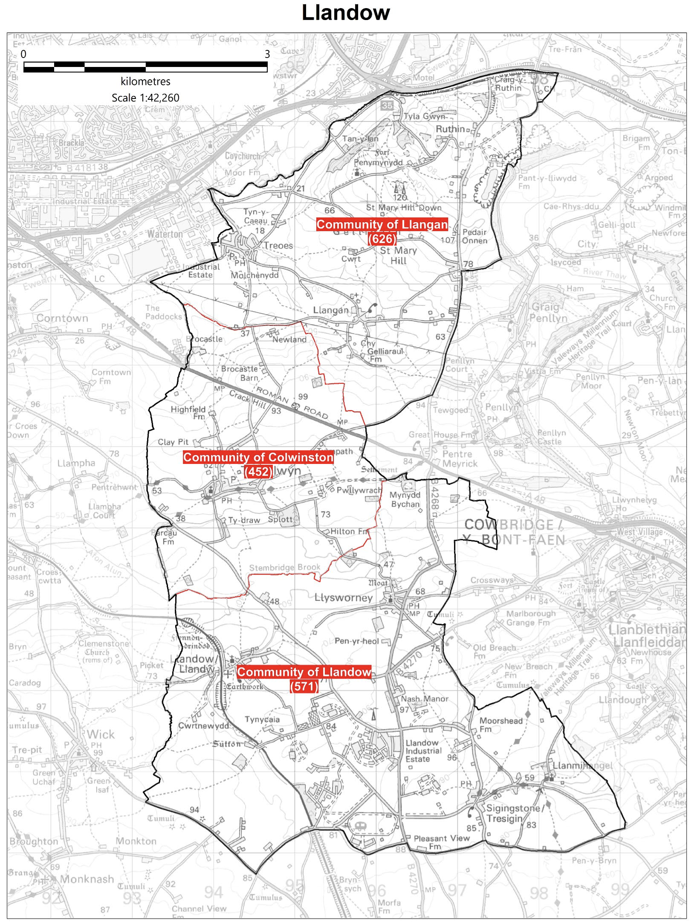

Cllr. Christine Cave email: cacave@valeofglamorgan.gov.uk
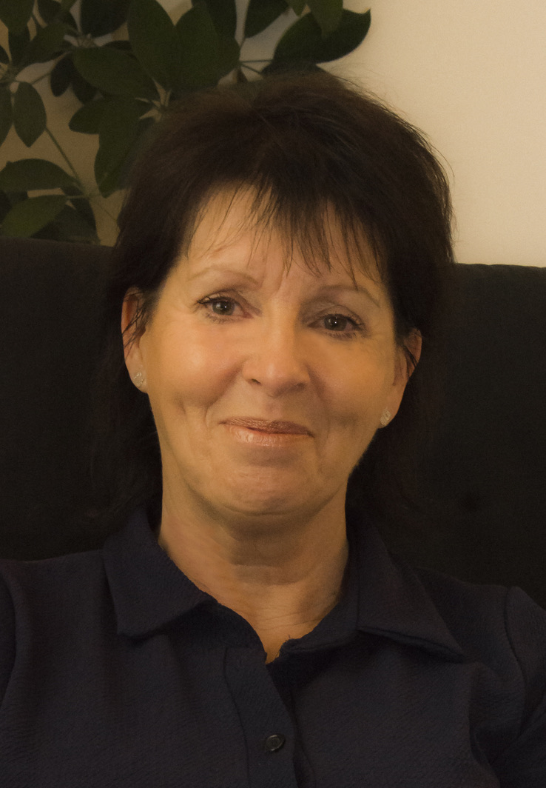

Date: September / October 2022- Report to the Community Councils (CC) in the Llandow Ward: Colwinston; Llandow/, Llysworney, Sigingstone, Sutton and Llangan/Treoes and St Mary Hill.

Vale of Glamorgan Council (VoGC) meetings:

Meetings of the Council will be taking place virtually (until further notice), will be live streamed and recorded for archive purposes.

View Remote Meeting Procedures

View Attendance at Local Authority Meetings Procedure (April 2021)

Vale of Glamorgan Full Council meeting date for 2022/23:-

26th September, 2022
5th December, 2022
6th March, 2023
24th April, 2023.

Full Council meeting 26th September 2022

1. Minute’s Silence for Her Late Majesty Queen Elizabeth II.

2. Apologies for absence.

3. (a) To hear the roll call of Members.
(b) To receive declarations of interest under the Council’s Code of Conduct.
(Note: Members seeking advice on this item are asked to contact the Monitoring Officer at least 48 hours before the meeting.)

4. To approve the minutes of the meeting held on 18th July, 2022.

5. To receive any announcements from the Mayor, Leader, Members of the Cabinet and the Head of Paid Service and to receive any petitions submitted by Members.

Report of the Chief Executive –
6. Use of the Chief Executive’s Emergency Powers.

Report of the Leader –
7. Amendments to the Council’s Constitution.

8. To consider the following proposal(s) from the Executive in relation to the Council’s Policy Framework and Budget

Item | Date of Meeting | Minute No.
(a) Annual Treasury Management Report 2021/22 | 21st July, 2022 | C48

N.B. The report which is the subject of the reference in respect of Agenda Items 8(a) above has already been circulated to Members with the Cabinet agenda for 21st July, 2022.

**Further copies are available from the Democratic Services Office if required**.

9. To receive questions and answers pursuant to Section 4.19.2 – 4.19.7 of the Council’s Constitution (i.e. questions on any matter in relation to which the Council has powers or duties or which affects the Vale of Glamorgan).

10. Questions from the public.
4 questions have been received.

11. Any items which the Mayor has decided are urgent (Part I).

Cabinet meeting Minutes of a hybrid meeting held on:
THURSDAY, 8TH SEPTEMBER, 2022 AT 2.00 PM

Agenda
1. Apologies for absence.
2. Minutes.
[View Minute]
3. To receive declarations of interest.
(Note: Members seeking advice on this item are asked to contact the Monitoring Officer at least 48 hours before the meeting).
[View Minute]
References –
4. Q4 Sickness Absence Report 2021/2022– Corporate Performance and Resources Scrutiny Committee, 16th June, 2022.
[View Minute]
5. Corporate Risk Register Quarter 4 Update – Governance and Audit Committee, 11th July, 2022.
[View Minute]
6. Award of Contracts for Supported Local Bus Services Call-In - Environment and Regeneration Scrutiny Committee: 12th July, 2022.
[View Minute]
Report of Meeting –
7. Cardiff Capital Region Regional Cabinet – 27th June, 2022.
[View Minute]
Reports of the Executive Leader and Cabinet Member for Performance and Resources –
8. Draft Vale of Glamorgan Council Annual-Self Assessment 2021/22.
[View Minute]
9. Use of the Chief Executive’s Emergency Powers.
[View Minute]

Reports of the Cabinet Member for Education, Arts and the Welsh Language –
10. Proposal to provide nursery provision at St. Nicholas Church in Wales Primary School.
[View Minute]
11. Vale of Glamorgan Council’s Draft Welsh in Education Strategic Plan (WESP) 2022-2032.
[View Minute]
Report of the Cabinet Member for Leisure, Sport and Well-being –
12. Tennis Court Refurbishments.
[View Minute]

Cabinet meeting held on: THURSDAY, 29TH SEPTEMBER, 2022
Agenda
1. Apologies for absence
2. Minutes.
3. To receive declarations of interest.
(Note: Members seeking advice on this item are asked to contact the Monitoring Officer at least 48 hours before the meeting).
Reference –
4. Sports and Play Update – Healthy Living and Social Care Scrutiny Committee, 6th September, 2022.
Reports of the Executive Leader and Cabinet Member for Performance and Resources –
5. Strategic Collaborative Working Initiatives Update.
6. Council Tax Discretionary Relief for Ukrainian Nationals.
7. Oracle Upgrade Update.
Report of Deputy Leader and Cabinet Member for Sustainable Places –
8. Amended School and College Transport Policy.
Reports of the Cabinet Member for Education, Arts and the Welsh Language –
9. Proposal to add St Richard Gwyn to the Capital Programme.
10. Purchase of Land at Lower Cosmeston Farm for Education Development for SEN School.
Report of the Cabinet Member for Social Care and Health –
11. Annual Report of the Director of Social Services 2021/22 – Final Version.

Report of the Cabinet Member for Community Engagement, Equalities and Regulatory Services –
12. Vale of Glamorgan Local Development Plan 2011-2026: Public Consultation on Draft Supplementary Planning Guidance on Retail and Town Centre Development and Economic Development, Employment Land and Premises.
13. Statues, Monuments, Street Names and Building Names - Review Panel – Update
Members of the Cabinet:
Councillor L. Burnett (Executive Leader and Cabinet Member for Performance and Resources)
Councillor B.E. Brooks (Deputy Leader and Cabinet Member for Sustainable Places)
Councillor R.M. Birch (Cabinet Member for Education, Arts and the Welsh Language)
Councillor M.R. Wilson (Cabinet Member for Neighbourhood and Building Services)
Councillor M.R. Wilkinson (Cabinet Member for Public Sector Housing and Tenant Engagement)
Councillor E. Williams (Cabinet Member for Social Care and Health)
Councillor S. Sivagnanam (Cabinet Member for Community Engagement, Equalities and Regulatory Services)
Councillor G. John (Cabinet Member for Leisure, Sport and Well-being)

Current Consultations
The Vale of Glamorgan Council current consultations section includes the work of the Council as well as other public organisations that operate in the Vale.
Integrated Sustainability Appraisal Draft Scoping Report Consultation
The Integrated Sustainability Appraisal (ISA) is being completed in order to consider and communicate the likely effects of the emerging Replacement Local Development Plan (RLDP), and suggest alternatives. It focuses on key sustainability issues and fulfils a number of legislative requirements. Preparation of the Draft ISA Scoping Report is the first stage of the ISA process.
ISA Consultation
Draft Recycling and Waste Strategy 2022-2032
Recycling and Waste Management is an essential service provided by the Council. It affects all of our residents, as well as local businesses and visitors to the county. This strategy will contribute to all of the organisation's objectives and the seven national well-being goals.
Draft Recycling and Waste Strategy
Your Penarth Esplanade - A thriving seafront for all
More than £500,000 has been invested in Penarth Pier Pavilion and the Esplanade in the last two years. The Vale of Glamorgan Council is now speaking to local residents, businesses, and community groups about how to further improve Penarth seafront and the surrounding area.
Your Penarth Esplanade
Help us decide the Vale of Glamorgan Council priorities for 2023/24
We're consulting on what we need to focus on for the future. To do this, we need to look at what we achieved and what we could have done differently. You can let us know whether you agree with our progress, commitments and objectives by completing our short survey.
Our Priorities for 2023/24 consultation
School and College Transport Policy
The Vale of Glamorgan Council aim to provide a reliable system of transportation to carry School and College students safely, punctually and in comfort. The Council are now consulting on an amended School and College Transport policy.
School and College Transport Policy 2022 consultation
Review of statues, monuments, street and building names and suggestions for future recognition and commemoration.
The Council is proactively reviewing all statues and commemorations in the Vale of Glamorgan. This work will ensure statues and commemorations on public land, as well as the names of streets and buildings are representative of local people’s values and those of a modern, inclusive Council. If you have seen a commemoration that you think should be reviewed to ensure it is appropriate, please complete our online form. Please ensure you include the location and reason for review.
Recognition and Commemoration
New Housing Development - Requirements for School Places
There are a number of new housing developments in the Vale. We are asking residents who are moving to new housing developments to let us know their requirements for school places. Please read the letter below and respond to the online survey.
- Letter to residents
- Online Survey
Consultation newsletter
If you'd like to receive our consultations directly, then please sign up to our mailing list.
Sign up
Local Matters
- Recycling Centre Llandow Industrial Estate – Response received from Miles Punter: “The date of 2024/25 remains ambitious, mainly on the basis that the acquisition of suitable land is proving difficult. We had recently identified a preferred site and we received positive feedback from the agent acting on behalf of the land owner, only for them to change their mind on submission of our bid, which notably, was above market value. We have expressed our concerns to the agent in the manner how this was undertaken but regrettably, we find ourselves again, looking for an alternative site in the western vale area.”
- Rural Road Traffic issues/road safety: identification of local road safety hotspots to inform way forward.
- Colwinston – Coffin stile –- ongoing.
- Colwinston – Heol CAe Pwll adoption raised with Miles Punter – response provided by Miles Punter – ongoing.
- Colwinston – Active travel plan awaiting response from legal team within the council following support from the CC.
- Colwinston – Junction on Church Lane and The Vines Colwinston road safety issue raised with VoG
- Colwinston - A48 Milestones - Crack Hill & Twmpath matter raised with conservation officer and highways team.
- Llandow – weight restriction signage and road layout Nash Junction/Llysworney speeding issues – ongoing, site meeting arranged attended in August, further meeting planned for September. Speedwatch issues raised with Alun Cairns MP. He has written directly to the Chief Constable of South Wales Police to ascertain the rationale behind recent decision making.
- Llandow – Llysworney Community Association meeting to discuss planning application for 10 flats – ongoing.
- Llandow – Sigingstone pre planning consultation, matters raised with local AM and others – application will come to the planning committee – new planning application made – ongoing.
- Llandow –dumping of rubbish on the industrial estate – further matters in relation to the industrial estate taken forward the planning/enforcement department – enforcement action to be taken – ongoing.
- Llandow – fly tipping reported and cleared close to the sewage treatment gates. Signage and camera requested for this area – ongoing.
- Llandow – Sigingstone Environmental Health officer contacted in relation to the activities at the go-kart track – Llandow CC monitoring the situation – ongoing.
- Llandow – Yes Cymru stickers have appeared on at various locations in the village on highways signage. Report made to highways team.
- Llangan – Parc Newydd - ongoing
- Llangan – Solar farm pre planning consultation Troeos – ongoing
- Various housing and home care issued raised with respective officers for the Western Vale – ongoing

Scheduled Meetings for October 2022 - All Meetings commence at 6.00 p.m. and be held virtually unless otherwise stated
Council |  | Early Retirement/Redundancy (4.00 p.m.) | 27 Oct
Annual Meeting |  | Licensing - Public Protection  (10.00 a.m.) | 4 Oct
Cabinet (2.00 p.m.) | 3 Oct;  17 Oct;  31 Oct  6 Oct;  20 Oct | Licensing - Statutory
Scrutiny (Corporate Performance and Resources)12 Oct | 12 Oct | Licensing Sub (1.00 p.m.) | 14 Oct
Scrutiny (Environment and Regeneration) | 11 Oct | Planning (4.00 p.m.) | 19 Oct
Scrutiny (Healthy Living and Social Care)  (5.00 p.m.) | 4 Oct | Public Rights of Way (10.00 a.m.)
Scrutiny (Homes and Safe Communities) | 5 Oct | Senior Management Appointment (9.00 a.m.) | 13 Oct
Reconvened Scrutiny (Learning and Culture) 5.00 p.m.  Scrutiny (Learning and Culture) immediately following the reconvened meeting | 6 Oct  6 Oct | Standards (9.30 a.m.) | 6 Oct
Appeals |  | Trust
Governance and Audit | 24 Oct | Vale of Glamorgan Local Access Forum
Community Liaison | 27 Oct | Voluntary Sector Joint Liaison | 24 Oct  17 Oct
Democratic Services (4.00 p.m.) |  | Welsh Church Act Estate (4.00 p.m.) | 10 Oct
Investigating |  | Shared Regulatory Services Joint Committee

